**ELEC/CPEG Final Year Project (2023-2024)**

**Project Final Poster – FYP Industry Day**

**Motivation**

The Project Final Poster (one poster per project) is intended to provide an overview of your Project to non-specialists of various kinds on various occasions. It will be made on-line available to the whole Internet world. **Students are required to present their Final Poster on the Industry Day, 14 May 2024 (Tuesday), students are required to FREE themselves for the whole day on the Day.** Details will be further announced in due course. It may also be selected and displayed in the ECE laboratory hallways and/or used in open-house presentations by the Department.

Students are encouraged to design and use the space in the provided poster size ([ECE_posterFormat.pptx](https://course.ece.ust.hk/fyp21/wp-content/uploads/2022/04/ECE_posterFormat_Final.pptx)) according to their requirements as long as 4 essential items of the ***Title Sheet*** are included.

Moreover, it is a component of your final grade! **Consult your supervisor and take his or her comments into account before finalizing the poster.**

**Your poster should be size A1 which is 59.4cm X 84.1cm.**

**Basic Poster Structure**

***Poster Layout:***

The general appearance is shown in the Poster Layout ([ECE_posterFormat.pdf](https://course.ece.ust.hk/fyp21/wp-content/uploads/2022/04/ECE_posterFormat_Final.pdf)). There are 3 sections:

1. The ***Title Sheet*** (9 cm x 76 cm) includes
2. Project title in 60 pt (or slightly larger) upper- and lower-case letters
3. Project code
4. Name(s) of the student(s) in 40 pt (or slightly larger) upper- and lower-case letters   
   (student I.D. is NOT required)
5. Name(s) of the project supervisor(s) in 40 pt (or slightly larger) upper- and lower-case letters   
   [prefaced by Dr./Professor (check with your project supervisor)]
6. The ***Logos*** (4.5 cm x 47.7 cm) which represent the University and the Department, are placed on the top of the board. The logos have a standard format and size, and are provided.
7. The design of the three ***Information Sheets*** (A4 size) as follows:
8. You should try to use paragraphs with centered titles, such as "Overview", and "Results", printed in 20-24 pt upper- and lower-case boldface letters.
9. Make effective use of titles for paragraphs, figures, etc. Use the typeface described in iii) below for the major part of the title (for visibility) and regular type for details.
10. The introductory paragraph(s) should be in a larger typeface than you will likely use in a detailed descriptive section. It should be readable at a distance of two to three meters (while the smallest type you use may be readable at distances of only one meter). Generally speaking, keep in mind that the larger and bolder your presentation is, the more enticing it will be to those seeing it at a distance. The real challenge, then, after you have attracted attention to your poster is to provide enough interesting and readable detail to someone who wants to learn more. One compromise might be to have some parts (e.g., notes included in small font with figures, or a section called "Detailed Design", or a Table) which are packed with useful information. However, don't forget, that important result should be big enough for reading at a reasonable distance!
11. A multi-column format can often improve readability by reducing line-length, allowing for more text structuring, etc.
12. Figures (including diagrams, charts, graphs, schematics, etc) are a good way to communicate interesting ideas.

***Formatting your Poster:***

*(Students may create the poster file directly with PowerPoint. Pls. read steps 2-6 for print quality requirements. Please be reminded to use* ***Microsoft Office 365 Powerpoint****)*

1. Students may use Microsoft Office Word to create the **Information Sheet (A4 size)**.
2. Before saving the file, make sure your document have

* all fonts in TrueType
* images in high resolution (300 dpi)
* color mode in RGB or CMYK
* no transparent fills  
  [Note: As advised by MTPC, there may be an unexpected printing result if the original Word document contains transparency, even though the PDF file look fine when displaying on screen.]

1. Download the Poster Template ([ECE_posterFormat.pptx](https://course.ece.ust.hk/fyp21/wp-content/uploads/2022/04/ECE_posterFormat_Final.pptx)) to create the poster file or open a single blank PowerPoint slide and set the page size to A1.

To set the page size to A1:

1. Click on the Design tab
2. Click on the Slide Size icon
3. Select Custom Slide Size form the drop down list
4. Type in the appropriate width and height.

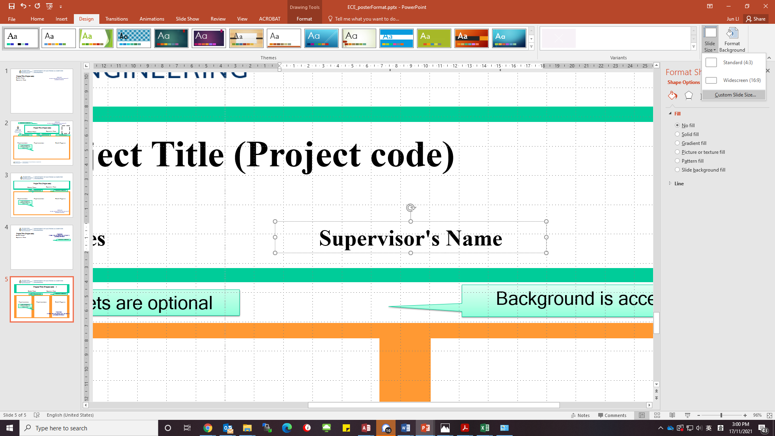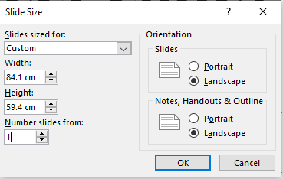

1. Select Insert > Object, click Create from file, browse and insert the saved Word document.

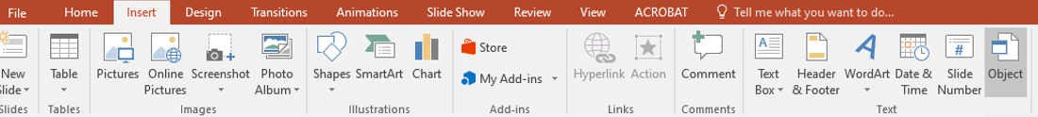

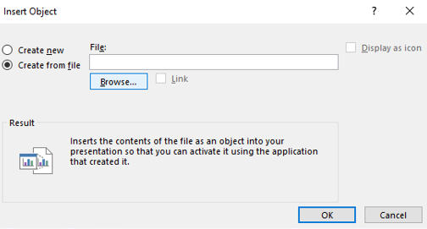

1. Adjust the size and put each section in the right place.
2. Save the poster Powerpoint using the **project code as the file name** (e.g. finalposter_TD1b-21.pptx)

Before exporting to PDF, make sure your PowerPoint document have fulfilled the print quality requirements.

1. Save the PPT again as PDF and use the **project code as the file name** (e.g. finalposter_TD1b-21.pdf)

**Submission Procedure**

Students should upload the following **TWO files** of the project poster to FYPMS **on or before the stipulated due date**.

* **one PowerPoint** file (e.g. finalposter_TD1b-21.pptx)
* **one PDF file** (e.g. finalposter_TD1b-21.pdf)

Please note:

* Hard copy of the project poster is NOT required.
* If you want to print it out for your own use, you may now place the order at the counter of MTPC Printing Workshop (Room 3104, via Lift 2).
* Any group member may upload the poster file for their group, but the system will only keep the most recently uploaded file. Older versions will be replaced by the newly uploaded file.
* Students may download their uploaded file for checking.
* Files received after the due date will be considered as Late Submission.

If you encounter any problem in uploading the files, please make an email inquiry at [eehelp@ece.ust.hk](mailto:eehelp@ece.ust.hk).